MUDD 6205: The Modern City: Theories and Forms
Fall 2021 Syllabus

COURSE INFO:
Meets: Mondays, 9:00 AM – 12:00 PM; CCB 1001
Credits: 3
Instructor: Associate Professor Nadia M. Anderson, she/her, nander35@uncc.edu
Office hours by appointment; City Building Lab CCB 1003, Storrs 142
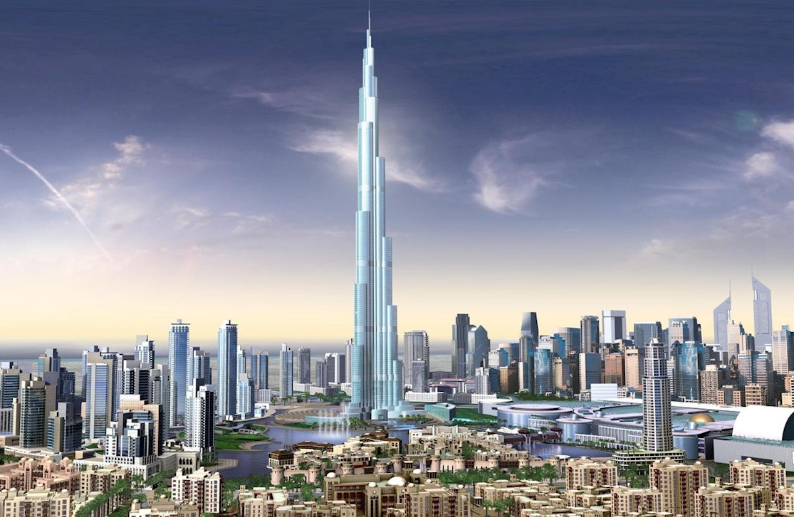
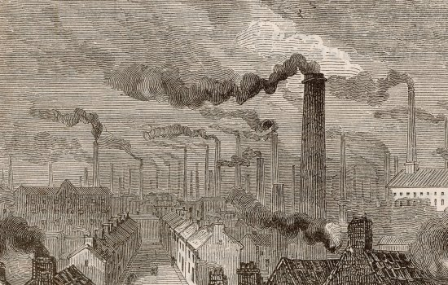
Manchester, England, 1870. Manchester Science & Industry Museum. Burj Khalifa, Dubai, ABB AbilityTM.

PREREQUISITES
This is a required course for students enrolled in the Master of Urban Design graduate degree program through the School of Architecture. It is also available as an elective for graduate students in other School of Architecture programs.

COURSE DESCRIPTION
This course investigates what the Modern City is and if it still exists or if we have moved into a new era. We will look at historical and contemporary examples that illustrate key ideas about modernity from historical and theoretical perspectives. The course focuses on the systems, themes, typologies that frame modernity not only in terms of urban design, architecture, landscape architecture, and urban planning but also art, philosophy, geography, and political economy. The goal is for students to be able to locate current urban design practices within larger cultural contexts and in doing so critically frame their design work and that of others.

COURSE METHOD and REQUIREMENTS
This course is scheduled to meet once per week for three hours. In-class meetings will concentrate on discussion of materials including readings and media that students must complete before the corresponding class sessions. Presentations by the instructor and students as well as guest visits will also be part of in-class meetings.

Class discussions will use the Harkness Method, developed at Phillips Exeter Academy in New Hampshire. This method focuses on student classroom leadership rather than faculty delivering information to passive students. It is a form of a “flipped” classroom.

Themes:
The course is organized around four thematic modules and one introductory module. The introductory module focuses on what “modern” means from multiple perspectives including the idea of the “modern city” as part of the on-going “modern project.” The four themes are Nature, Infrastructure, Property, and People. Each module is three weeks long and includes relevant readings, instructor lectures, various media (e.g. films), and student presentations. There is considerable overlap between themes; please consider the modules as an organizing device rather than separate categorization. For example, a few concepts or systems that permeate the themes include continuous progress/growth, importance of technology, increasing urbanization, individuality (including democracy), and the role(s) of capital and labor.
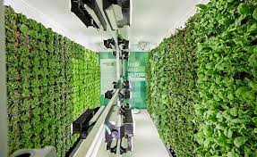
Industrial Agriculture Vertical Farming

Grading will be determined by the percentages indicated below. Reading Reflections will be pass/fail based on whether or not they are submitted. All other components will receive letter grades. Grades will follow the UNC Charlotte Graduate School’s grading scale. Grading rubrics are included in the Canvas gradebook and assignment descriptions.

1. Reading Reflections and Discussion Questions: 25%. For each week that there are assigned readings, students are responsible for writing a reflection connecting topics discussed in the readings to today’s world, issues of personal importance. This may be about contemporary urban design but does not have to be; it can be about any aspect of contemporary life. This is not a reading summary; it should be in your own words and express where you found meaning in the readings (or if you didn’t, explain why). You can include links to current media (article, podcast, TV episode, song, etc.) to help demonstrate your ideas.

You will use your reflection to generate a question or select a quote that you will be asked to express in class as a discussion-starter (see Harkness Method above). Reflections are due by a day, time that will be agreed upon during the first class.

2. Individual Presentations: 35%. Each student will be responsible for preparing a case study presentation on one or more urban projects or actions related to their theme. These will typically occur on the second week of each three-week module. The instructor will provide a list of suggested presentation topics and students may suggest their own topics. The student will also provide a reading related to the presentation. Additional details will be provided in the Canvas Assignment.

3. Issue Map: 40%. The last part of the semester will synthesize topics from the course by mapping an important contemporary issue in a specific geographic part of Charlotte using that area’s history as related to theories and historical examples from the course. The goal is to reveal current relationships between spatial actions, policies and socio-economic issues by looking at history through a theoretical lens related to the Modern City.
An initial proposal including a research question, preliminary draft, and final product will be submitted according to a schedule provided as part of the detailed assignment. Final presentations will occur during Finals Week.

COURSE ETIQUETTE
The richness of our varied histories and backgrounds is a tremendous opportunity for dialogue and learning. This class is a safe space where you can participate freely without concern for how "correct" your ideas may be. Histories are framed by contemporary and historical contexts and vary based on perspective. You can bring your past experiences, current events, and learning from other courses in as much as you are comfortable. No one should ever feel compelled to share personal experiences or speak as a representative for anyone other than themselves.
All students must respect their instructor, classmates and guests! Please do not make derogatory comments, talk while someone else has the floor, or use cell phones or other devices. If you are uncertain how a question may be perceived, begin talking about this uncertainty and be willing to receive suggestions. If you feel that someone (including me) has spoken to or about you or another classmate, group, or identity in a way that is disrespectful, is a microaggression, or constitutes gaslighting please let me know as soon as possible in whatever way you feel is most comfortable. You may confront me, a classmate, or a guest directly if you are comfortable doing that but you should not feel pressured to do so.
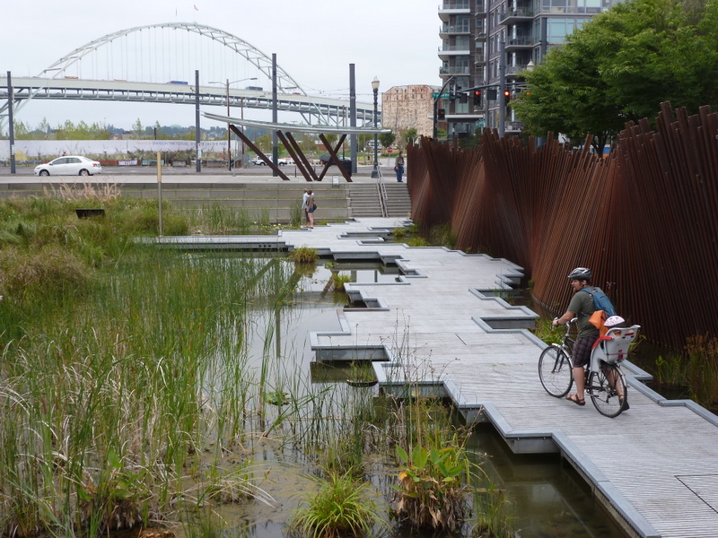
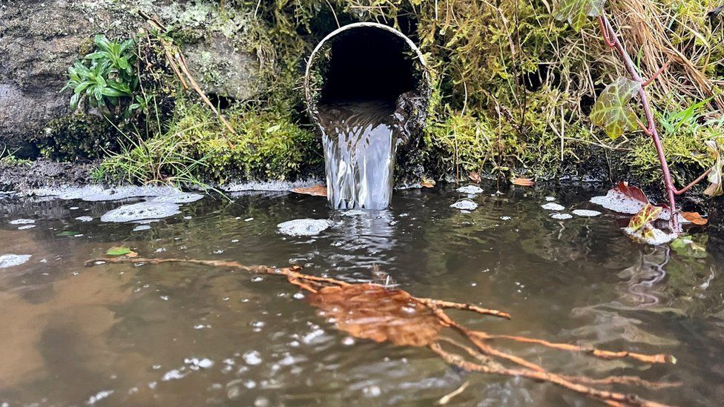
ALWAYS use language that is as inclusive and gender-neutral as possible. This means that instead of saying "mankind" you need to say "humankind." We may have contemporary or, particularly, historical readings or materials that do not practice this kind of inclusive language. Consider what power structures this shows, who it empowers and who it disempowers. For general reference to an individual you may use "he or she" or "they" when speaking; in writing "he or she," "s/he," or "they" is acceptable. Note that while "they" is not universally accepted as proper reference to a single person, it is inclusive of non-binary gender identities and will be accepted in written, visual, and verbal contexts. You may use non-inclusive language for direct quotes.

Untreated stormwater overflow, Yorkshire, England. Tanner Springs Park green infrastructure, Portland, OR.

SEMESTER SCHEDULE

Week | Theme | Readings | Activities/Assignments
1  8/22 | Introduction: Course organization, Themes of Modernism
2  8/29 | What is Modern? |  | Reading Reflection
3  9/5 | Labor Day – No Class  What is Modern? |  | Reading Reflection  Online Discussion
4  9/12 | Nature |  | Reading Reflection
5  9/19 | Nature |  | Reading Reflection  Student Presentation
6  9/26 | Nature |  | Reading Reflection
7  10/3 | Infrastructure |  | Reading Reflection
8  10/10 | Fall Break – No Class  Infrastructure |  | Reading Reflection  Online Discussion
9  10/17 | Infrastructure |  | Reading Reflection  Student Presentation
10  10/24 | Property |  | Reading Reflection
11  10/31 | Property |  | Reading Reflection  Student Presentation
12  11/7 | Property |  | Reading Reflection
13  11/14 | People |  | Reading Reflection
14  11/21 | People |  | Reading Reflection  Student Presentation
15  11/28 | People |  | Reading Reflection
16  12/5 | Review Week – Individual Meetings by appointment
17  12/12 | Final Presentations – date TBD
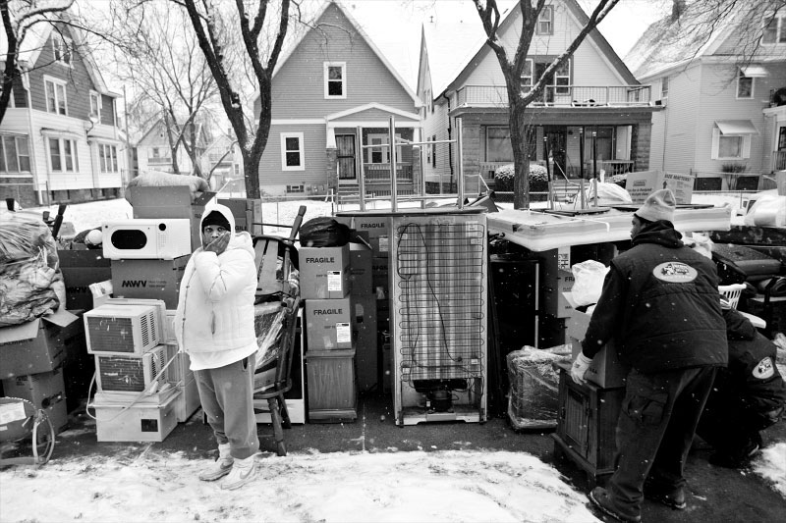
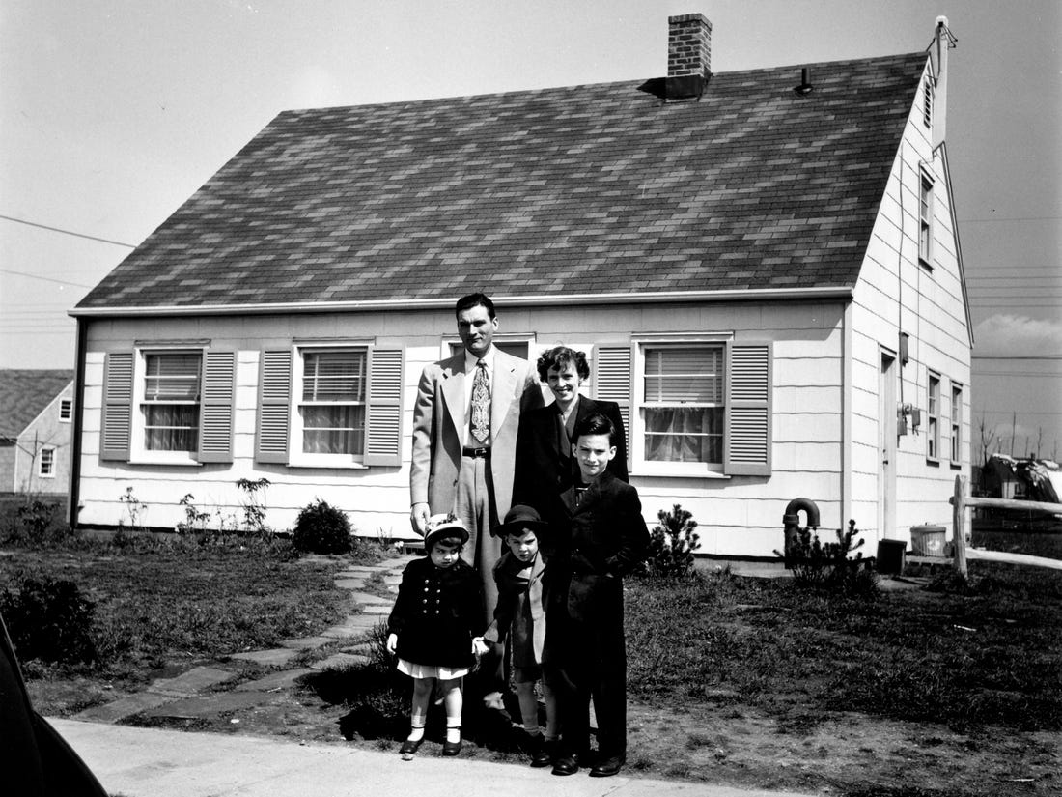
Levittown, New York, 1950. Milwaukee, Wisconsin, 2018.

COURSE POLICIES
Please refer to the UNC Charlotte School of Architecture General Course Policies document for descriptions and links to university and Graduate School policies. This document is also available in the Course Documents folder on the course Canvas site. Topics covered include:
- Student and faculty responsibilities
- Culture
- Diversity + Inclusion
- COVID-19 Protection (additional information, changes available through the Student Health Center)
- Electronics
- Recording Courses
- Facilities
- Academic Integrity
- Harassment
- Disability
- Communication
- Note that UNC Charlotte email will be the primary form of contact between instructor and students
- Course website – we will generally use Canvas for documents, readings, assignment submissions; a Google Drive may be established if appropriate, useful
- Writing
- Attendance – more than two unexcused absences will impact course grade; inform instructor of any excused absence as soon as possible and no later than 9 AM on the morning of the absence.
- Religious Holy Days
- Student Workload and Late Work
- Grading (general; course-specific criteria described above)

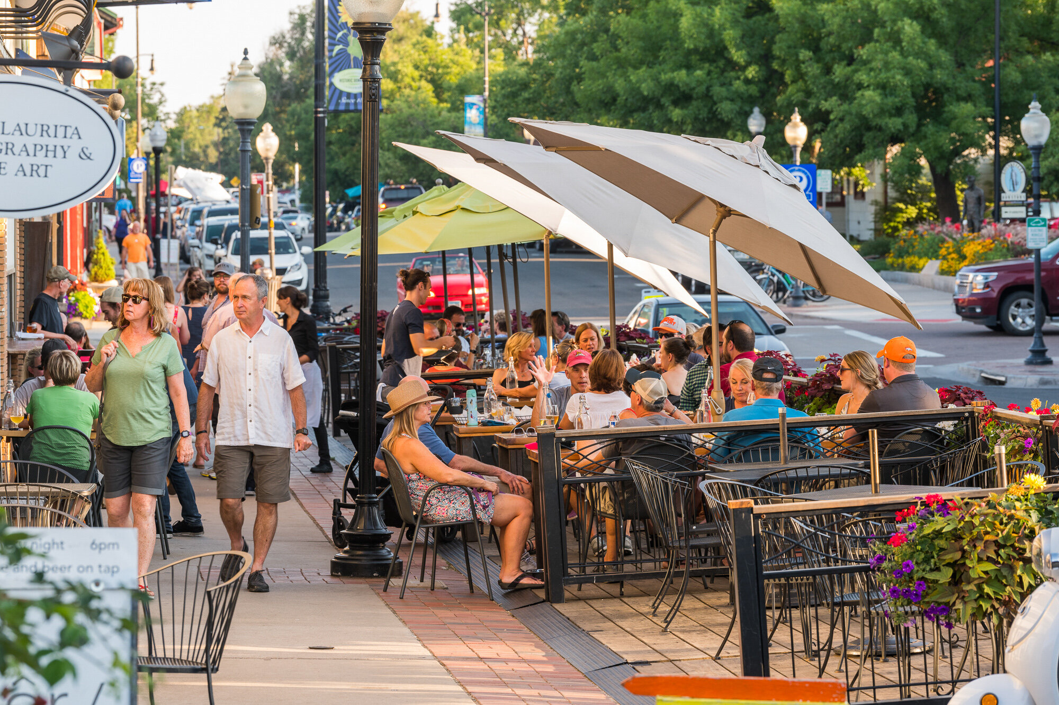
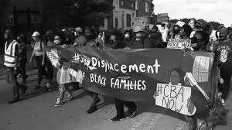
Public Space. Public Space.

