Course Description ARCH 4050/5050 008
Dilemmas of Modern City Planning: Equity in Design Fall 2023
Deb Ryan, Landscape Architect Emeritus, UNCC Professor of Architecture and Urban Design (deryan@uncc.edu)
Friday mornings 9:00am – 11:30 at the UNCC Dubois Center City Building 3.0 Credits
Hybrid Instructional Method, In-person Class and Local Field Trips, Occasionally Online

In cities in the United States, we cannot pretend that all bodies have the freedom to move through, occupy, and enjoy public space.
The perception of black and brown bodies gathering in public space routinely reads as suspect, criminal, or illegitimate.
Peoples’ rights to convene or congregate becomes interrupted, sometimes–ever more frequently–through limitation,
denied access, and force. If your very existence is read as a violation, is public space really for you?
Isis Ferguson, Place Lab
PREMISE: Economics, social forces, attitudes about density, ideas about sustainability, and incentives to encourage good design are all forces that contribute to contemporary urban form. A city’s plans illustrate a response to these forces and can define a vision for its future. However, underlying these forces is a history of intentional segregation, a byproduct of explicit government policies at the local, state, and federal levels. The impact from these policies has been devastating for generations of African-Americans and other people of color who have suffered from state-sanctioned violations of the Bill of Rights.

Throughout the twentieth century, the legal system in the United States upheld discriminatory policies to maintain the segregation of whites and blacks, significantly contributing to the racial unrest now taking place on the streets of American cities. Charlotte is no exception. Here, racial and economic segregation are not age-old givens, but products of a decades-long process.

(Image citation https://vakids.org/our-news/blog/race-place-and-poverty-presentation-for-greater-richmond)
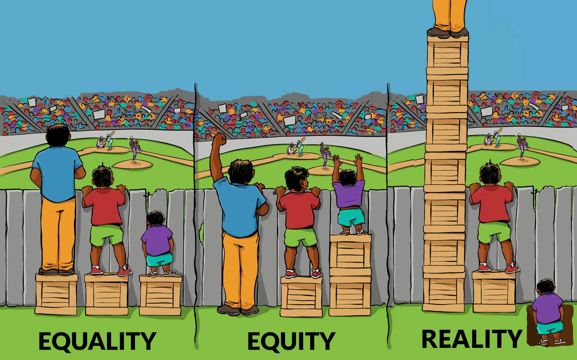
METHOD: Students will become familiar with Charlotte’s urban form through videos, readings, class presentations and discussions, case studies, and research projects. Field trips to the neighborhoods discussed in class will also be taken.

CONTENT: This is a class about how local, state and national policies combined to create Charlotte’s urban form, and how race was a fundamental contributor. It is an introductory course for advanced undergraduates and graduates that examines both the evolving structure of the American metropolis and the ways that it can be designed and developed. Students will benefit from a wide range of local speakers who have addressed urban problems and acted to alter cities, suburbs, and regions through modern city design and planning. We will consider the values implicit in their decision making, stressing the connections between attitudes, ideas and design. We will focus on equitable practices and principles in the design of cities. Attempts to control growth and gentrification will also be covered. Topics will include equitable urban infrastructure, gentrification, urban open space, social capital, healthy communities, and urban vitality.

OBJECTIVES:
• To consider community design and planning through an equity lens.
• To explore the enduring impact of public policies that resulted in the segregation of American cities.
• To become familiar with Charlotte’s historical neighborhoods, and consider the forces that have contributed to their rise, fall and gentrification.
• To understand the personal and societal impact of urban renewal, evictions and displacement in the US and especially in Charlotte
• To consider how race and economic mobility are intertwined
• To consider the range of remedies and resources needed and/or available to correct past inequities in urban form
• To become aware of what the city of Charlotte is currently doing to address historic inequities in public space, and meet some of the local leaders who are affecting change

EVALUATION & GRADING:
Evaluation will be based on the following:
Quiz Taking and Class Participation: 30%
Research Projects 45%
Final Project 25%

TEXTBOOKS:
• Tom Hanchett, Sorting Out the New South City: Race Class and Urban Development in Charlotte, 1875- 1975
• Richard Rothenstein, The Color of Law: A Forgotten History of How Our Government Segregated America

