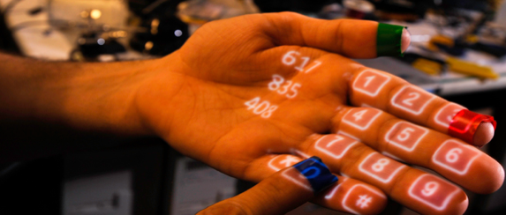
ARCH 7101 – TOPICAL STUDIO
Space + Technology @ Burson hall
Fall 2021
WWF 2:00-5:30 (see note below)
University of North Carolina at Charlotte, School of Architecture
Eric Sauda,
Dr. Mary Lou Maher, Human Computer Interaction Director, CCI
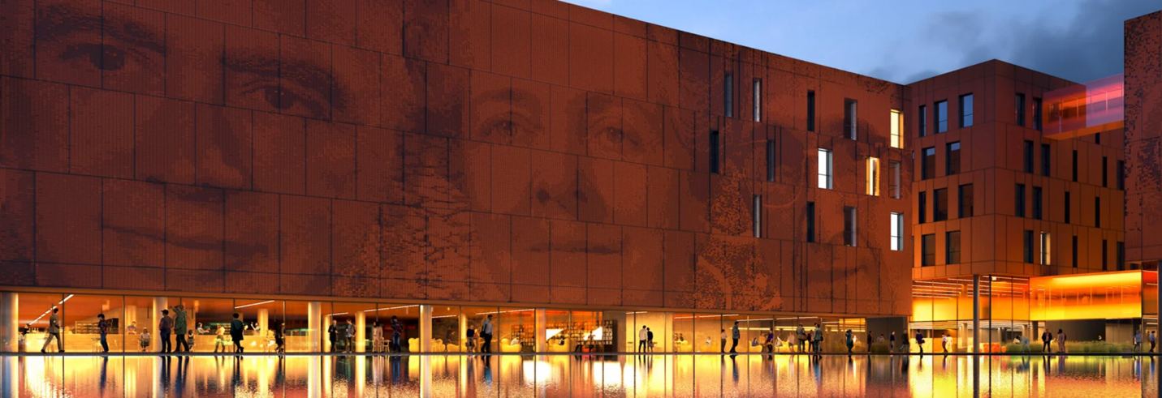
Carlo Ratti, University of Milan Science Building
Premise
We will be working in collaboration with students and professors from SIS on the design of spaces that integrate the uses of technology into spatial settings. Academic Affairs has asked the College of Computing and Informatics to consider how the second floor of Burson might be used once renovation funds become available. There are also possible cascading questions/designs needed for Woodward. A key requirement is that the renovated spaces function as a living laboratory that promotes innovation and explores the integration of technology and space.
We are lucky to be collaborating with Dr. Mary Lou Maher, who is a recognized expert worldwide on these issues. We will also be collaborating with her Human Computing Interaction students. We will meet jointly with those students during their class periods
The overlap between the issues and concerns of human interaction design and architects makes for a rich and rewarding dialogue. We will be able to test our ideas and concepts with experts in the field. We also have the opportunity to work closely with students who share our interest but approach them with different methods.
At the end of the semester, we will jointly present our work to the Chancellor and Provost as a vision for the renovation of Burson.

Scheduling note
To facilitate our collaboration with the HCI students, during the second half of the semester we will sometimes move one class meeting time per week from its normal in person time to an online meeting time with the HCI class on either Tuesday or Thursday from 5:30 to 8:15.

Bibliography
Paul Dourish, Where the Action Is: The Foundations of Embodied Interaction

