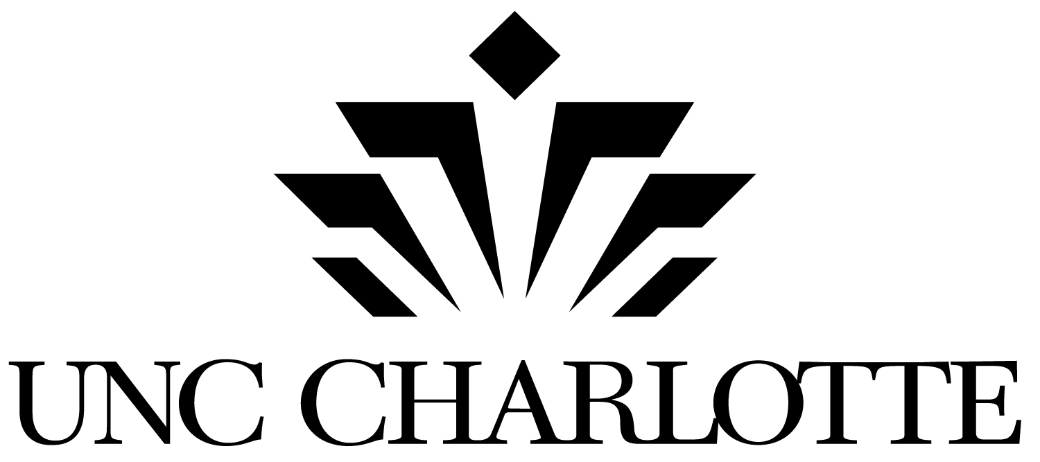
College of Arts + Architecture
Department of Music
www.music.uncc.edu
9201 University City Blvd.
Charlotte, NC 28223

3 January 2017

Dear Parents, Family Members, or Guardians:

The Department of Music at UNC Charlotte is again offering to elementary-aged children a free opportunity: the UNC Charlotte Children’s Choir. For fourteen (14) weeks beginning 23 January 2017 students in grades three through five may participate in a choral ensemble under the leadership of artistic director Ginger Wyrick. Professor Wyrick is widely sought-after choral conductor, pedagogue, and expert in children’s choral music and directs the Children’s Choir. This opportunity is being offered to students free of charge. University music education students will also assist in teaching the choir students.

Your child has been selected by your music teacher to participate in the UNC Charlotte Children’s Choir, and, I also invite your child to be a part of an exciting music making experience with Ms. Wyrick. Please fill out the registration and either mail or fax it to me, or please bring it on the first day of rehearsals.

Rehearsals will be on the campus of UNC Charlotte in the Robinson Hall for the Performing Arts on Mondays, 4:45-6:00 beginning 23 January 2017. Students may be dropped off at the front entrance of Robinson Hall and will be greeted by a Choir Assistant (look for the adult wearing a name badge), and then picked up in the same location. At the end of the semester, a performance of the children’s work will be presented for parents and the community in the Ann R. Belk Theatre in Robinson Hall on our campus. Please see the Registration Form and Calendar of Rehearsals. There is also a campus map for you; Robinson Hall is Building #51 on the map.

I encourage your child’s participation with our students and with Professor Wyrick. Please feel free to contact me for additional information.

Respectfully,
Fred P. Spano, PhD
Associate Professor & Coordinator of Music Education
The University of North Carolina at Charlotte | Department of Music
341 Robinson Hall
Charlotte, NC 28223
704-687-0263
fspano@uncc.edu

