7103 Peter Wong Spring 2021 SoA UNCCharlotte
7103

Living Rubrics: emergent techniques for space-house-city
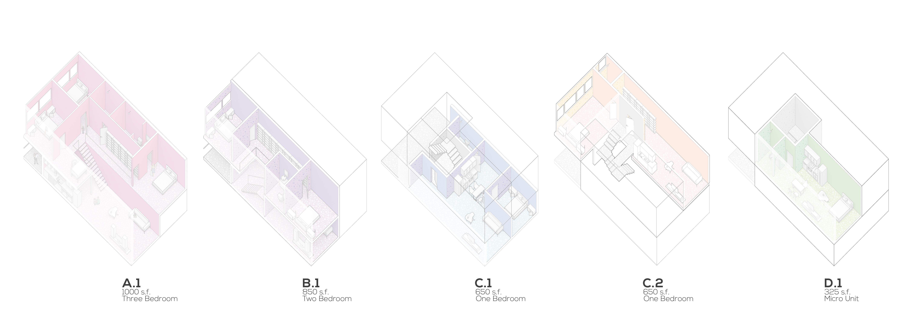
Unit Types, 2019 Timber in the City.

Course Info
7103-00_ | Grad Topics Studio | Sp 2021 | MW F 2:00-5:15p | prerequisite 7101 | Peter Wong | online | plwong@uncc.edu

Premise
Architecture is full of camps. Form, space, and composition rule for the artistic architect, sustainable solutions are championed by the environmental designer, socially-responsible leaders speak of equity and design activism, and the digital crowd find power in data and the promise of automated form. Of course, there are many more orientations for design that architects might align themselves with, in the end it becomes confusing to know which path is most important, which one to follow. Simultaneously, there are designers, such as Michael Meredith of MOS, that speak of a position of indifference, a denial of sorts to join any particular camp, a flinch that resists excluding all possibilities.

This studio begins with a premise that design is a web of concerns that privileges no one attribute or problem over another. We will start with space, by considering the history and possibilities of housing design as an elemental problem of configuration, inhabitation, and systemic reasoning. Next, we will work with contemporary construction methods that are sustainable but also present particular technical and regulatory problems that lie on the forefront of innovation. Lastly, we will work with the issues of affordability and equity, working to address social and urban issues by way of your design talents but also involving in the process public sentiment as well as equitable ethics in measured ways.

The project to explore these issues will be a residential multi-family complex in a major US city. The technology will explore the use of mass timber construction, a relatively new building material in urban environments. In addition, we will diversify the units of this complex and array them with a range of sizes and economically diverse living solutions. You will also employ computational strategies as a way to form find and program.

Method and Content
The class will be structured as a studio design course. Readings, case studies, and housing prototypes will comprise the first part of the semester. The remaining two-thirds of the class will involve design alternatives and a solution that aims to be comprehensive and holistic in its attempt to solve the housing program and issues outlined above. There will be public presentation events as well as a possible field study for the class (TBA).

Bibliography
Background essays, articles, and chapter readings by the instructor, TBA.

Evaluations / Grading
UNCCharlotte graduate grading scales shall apply. Grade distribution: research (15%), design (75%), engagement/participation/attendance (10%)

