Arch 5204
Sauda
Monday, Wednesday, 11:00 – 12:20
Data Analytic Methods
Data, Architecture and Contemporary City
“The NSA's Utah Data Center will be able to handle and process five zettabytes (the amount of data that would fill 250 billion DVDs) of data, according to William Binney, a former NSA technical director. Binney's calculation is an estimate. An NSA spokeswoman says the actual data capacity of the center is classified. ‘They would have plenty of space with five zettabytes to store at least something on the order of 100 years worth of the worldwide communications, phones and emails…’”
Howard Bircus, NPR, “Amid Data Controversy, NSA Builds Its Biggest Data Farm”

“I began this article by saying that quantitative data are useful because they are independent of interpretation; then, that they are interesting because they demand an interpretation; and now, most radically, we see them challenge existing interpretations, and ask for a theory, not so much of ‘the’ novel, but of a whole family of novelistic forms. A theory of diversity. . “
Franco Moretti, Graphs, Maps, Trees: Abstract Models for Literary History

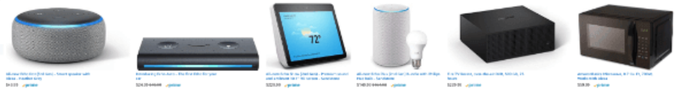
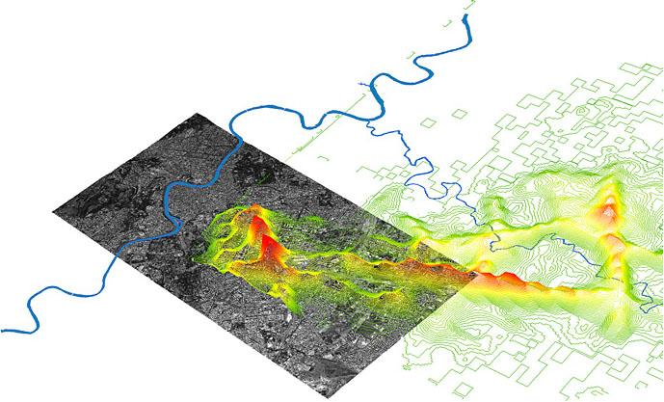
Premise
It is by now obvious that instant communication and the flow of data will become permanent features at all spatial levels from the most personal and private to the largest and most public. This transition has been the subject of a long historical discourse as well as active research by planners, designers and computer scientists.
This class will develop an understanding of the historical literature that theorizes the influences of new communication technologies, and use advanced methods of data acquisition and analysis to understand new forms of architecture and contemporary urbanism.

Objectives & Content
We will begin with intensive reading of theoretical and practical perspectives on data and space.
We will then proceed to propose research questions that can be answered by the analysis of communication and data.
We will use the API (application Programming Interface) from Twitter, Googleand other sources to collect data.
We will use Topic Modeling and Event Modeling to analyze this data
Each student will write a research paper that presents a literature review, methods, findings and collusions.
Upon completing this course, a student will:
- Understand the discourse concerning the influence of communication and data on space.
- Be able to collect large amounts of data.
- Be able to analyze and interpret data as it relates to ideas of space.

Texts
- Thirdspace: Journeys to Los Angeles and Other Real-and-Imagined Places, Ed Soja
- Telecommunications and the City, Stephen Graham and Simon Marvin
- Mobile Interface Theory, Jason Farman
- Understanding Media: The Extensions of Man, Marshall MacCluhan
- The Aesthetics of Disappearance, Paul Virilio
- Me++: The Cyborg Self and the Networked City, William Mitchell

