7201 Wong Fall 2021 SoA UNCCharlotte

7201 DESIGN METHODOLOGIES

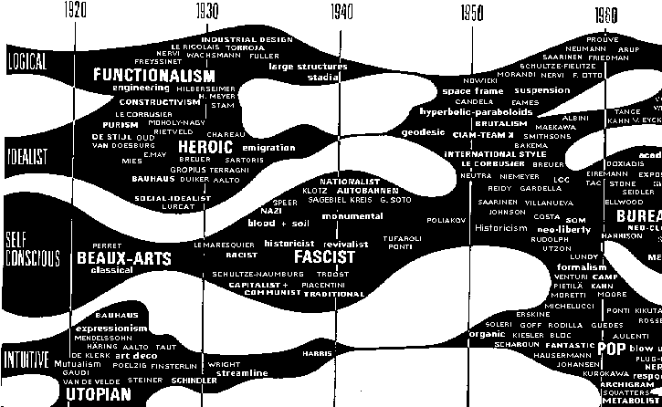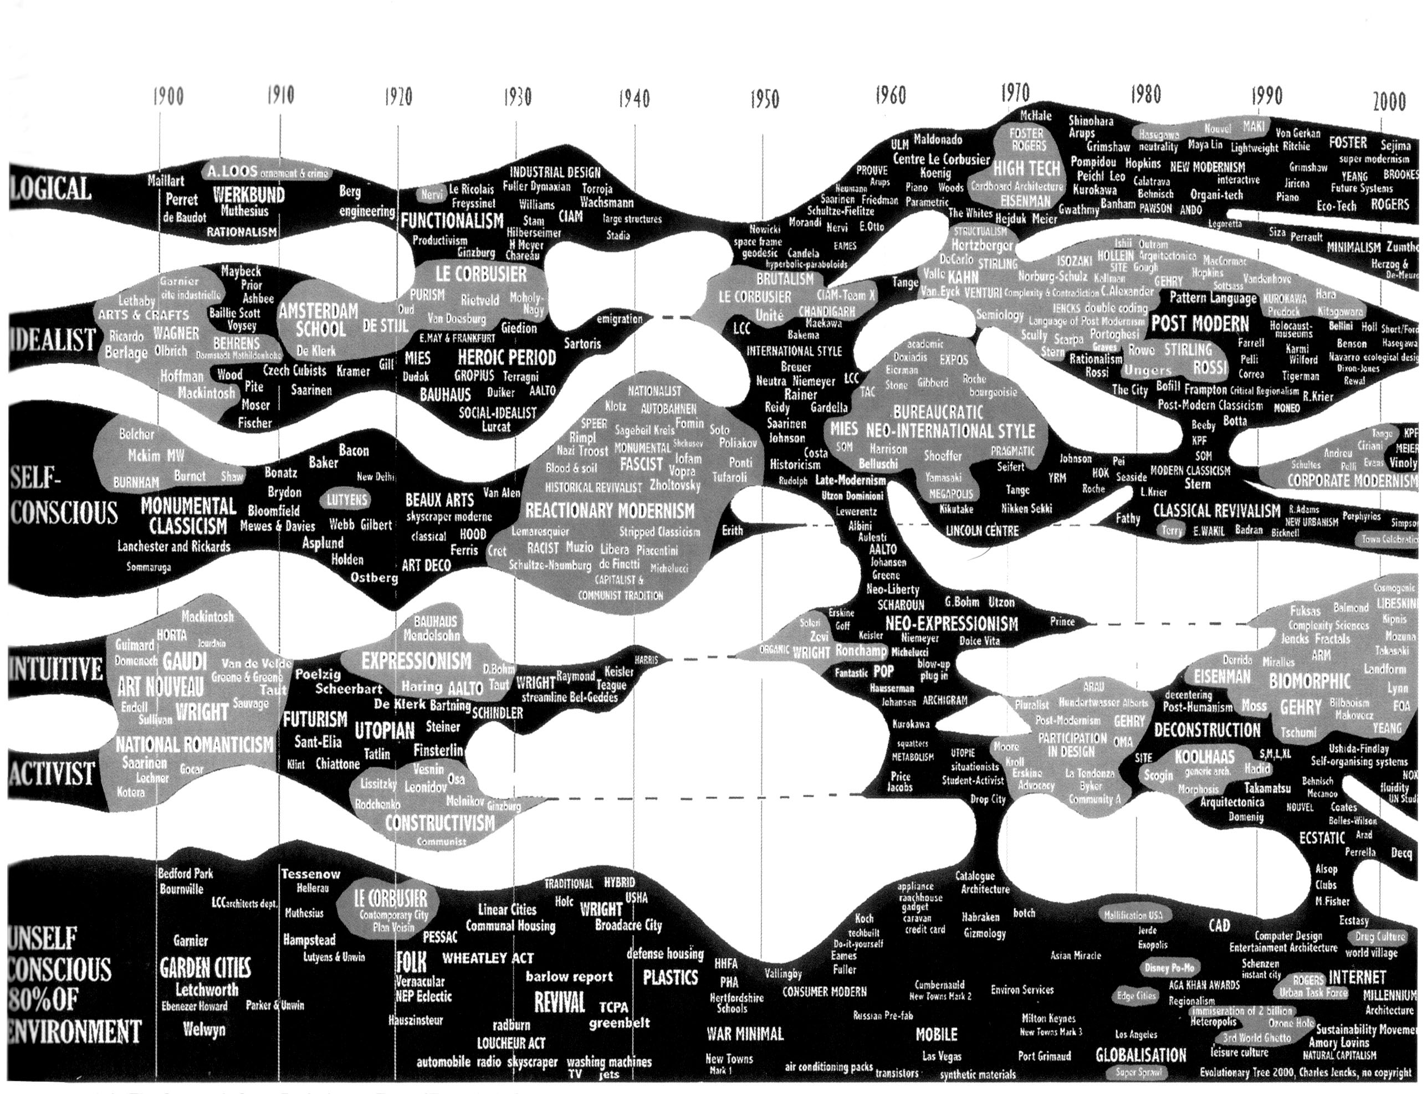
Charles Jencks, Evolution Tree, 1980 and 2000.

Premise
Charles Jencks once said that “architecture, and all art, should be content-driven,” implying that buildings, and their architects, have something to say, something to prove, or perhaps things to offer. Finding the premise for architecture has always been a part of the modernist project, whether it involves the lessons of divine rules (Alberti), scientific reason (Durand), or the art of the social rebuilding of post-WWII civilization (Corbusier). Today’s content-driven architecture follows the same path as the promises made by past architectures – e.g., the vision of computationally-driven algorithms, zero-carbon models, and/or equity-based building solutions. What is less focused on today are the means by which these directives are achieved, the specific modes of production, and the methodologies that operate at different levels of effectiveness. Design Methodologies is not a single solution to the themes that incite motives for building but rather a collection of operations that we see as contemporary mechanisms for practicing the production of buildings.

Method and Content
This class will be structured in three parts. The first will consist of a series of lectures and examples that survey five (5) of the most common methods used by contemporary architects today. The second will involve a series of workshops and written assignments that allow students to examine the role these methods play in the creation of modern architectural practices. The final segment of the class asks students to compile a comparative study report incorporating one of the five methods they feel is important in carrying the content of an architectural directive that they believe is critical and pressing.

Schedule
The following schedule will be employed during the semester:

week topic / activity

1 Introduction
2 1. Precedent and Historical Methods
3 2. Literary and Narrative Models
4 3. Information and Data Collecting Methods
5 4. Prototyping
6 5. Surveys, Interviews, and Collaborations
7 Workshop 1
8 Workshop 2 (report proposals due)
9 Workshop 3 (report drafts due Nov. 6)
10 critique session
11 instructor meetings
12 Report Presentations 1
13 Report Presentations 2
16 Final Reports due (finals week)

NAAB
ARCH 7201 will address the following NAAB criteria: A3: Investigative Skills, A.6: Use of Precedents, and C.1: Research. (As required, these criteria may be updated to comply to current NAAB standards.)

Bibliography
Recommended texts: Raymond Lucas, Research Methods for Architecture (London: Lawrence King, 2016). Optional text includes: Linda Groat, and David Wang. Architectural Research Methods, 3rd edition (New York: John Wiley & Sons, Inc., 2002). Additional texts, individual essays, articles, and chapters shall be assigned by the instructor in class.

Evaluations / Grading
UNCCharlotte graduate grading scale shall be used as defined in the current University catalog. Distribution and weight of the course evaluation includes: (1) methodology readings and discussion (10%), workshops (15%), semester report presentations and final submission 70%, and attendance/participation 5%. The option for Pass/No Credit may be offered according to University regulations.

Additional Course Standards
Refer to SoA supplemental syllabus requirements (attached).

I would argue that architects and architecture, both now and in the past, have productively instrumentalized indifference, and that indifference played a central role in both modernism and postmodernism by contrasting strong politics with weak or empty forms; by cooling things down; by developing noncomposition; by focusing on the systematic, on typology, or on distancing techniques, ambiguity, chance operations, nonauthorship, and positivist logic(s); and by employing the antiaesthetic aesthetics of appropriation, ready-mades, and lists. Yet even if indifference (antiexpressionism) indeed lay at the core of modernism … it is clearly also of the here and now.

–Michael Meredith

