Spring 2019 ARCH4202/5202 Architectural History II: 1750-Present
Instructor: Lidia Klein
Tuesdays/Thursdays 11:30am-12:45pm, course (undergraduate and graduate students)
Tuesdays 10:00am-11:15am (recitations for graduate students)

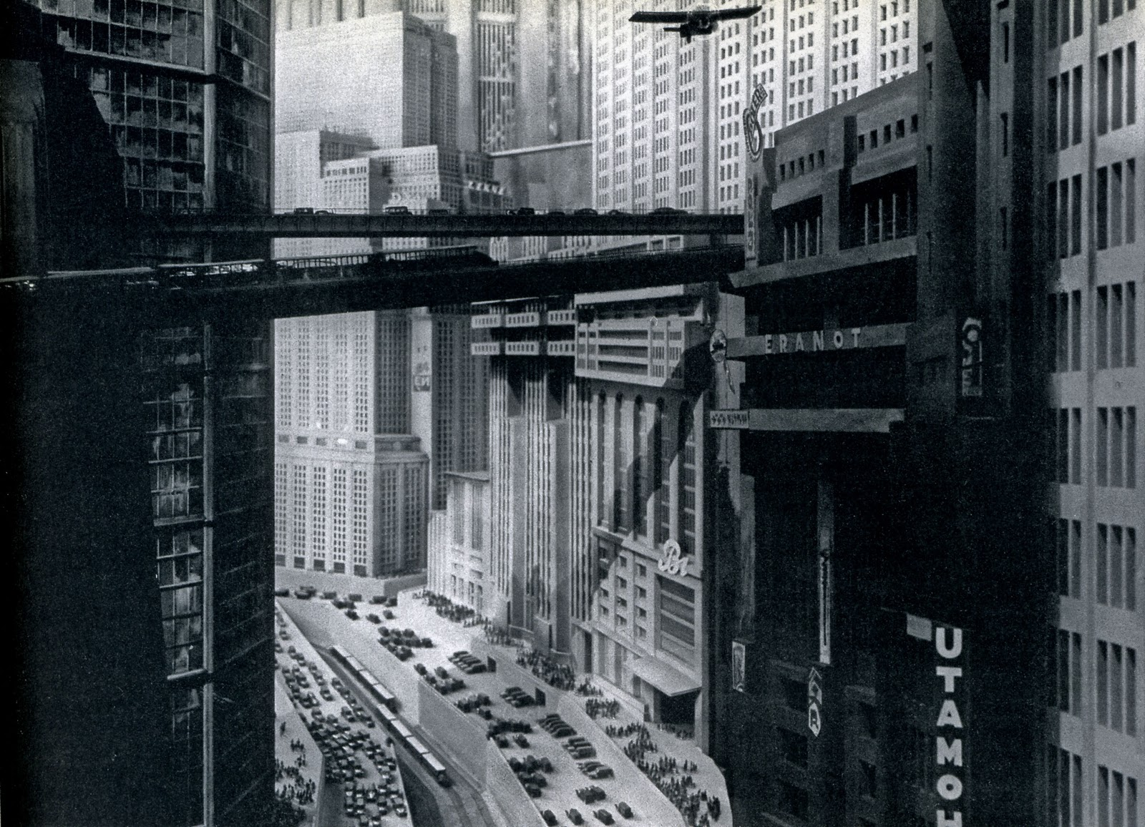
Metropolis (1927), dir. Fritz Lang

Premise: This course provides a survey of architecture from 1750 to the end of the twentieth century. We will consider architecture in its cultural, political, social and economic contexts and will examine the relation between architecture and key forces/phenomena shaping culture and society post-1750, such as colonialism, imperialism, industrialization and modernity. The course aims to examine architecture as a part of broader changes in design and art. We will put emphasis on the connections between architecture and other branches of design of different scales, from urban design and interior design to industrial design and fashion.

Objectives:

- To acquire knowledge of the practice and theory of architecture from 1750 to the end of the twentieth century;
- To understand the relations between architecture and broader cultural, political, social and economic changes of the time;
- To understand the relations between architecture and the disciplines of design and art.

Method: This course is organized as a combination of lectures, discussions and presentations.

