Spring 2019, Elective Seminar Architecture and Production: from Assembly Line to 3-D Printing (Instructor: Lidia Klein)

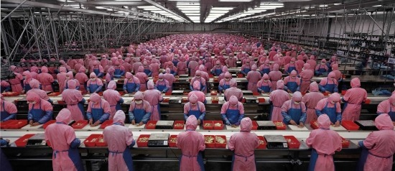
Edward Burtynsky, Manufacturing #17, 2005

Premise: In this seminar we will examine architecture’s immediate relationship with production. The course covers the time period from the nineteenth century to the present, and is focused on two questions: 1. What are architectural responses to the changing systems of production as well as the economic, political, and social conditions causing these changes? 2. What are the social and cultural implications of changing methods of architectural production?

In the first part of the course we will examine chronologically the relations between modern and contemporary modes of production, from industrialization, Taylorism, and Fordism to post-Fordism. In the second part of the semester, we will investigate methods such as digital fabrication, 3-D printing, user participation, DIY techniques, and the revival of traditional craft practices, and reflect on broad social and cultural consequences of their use in architecture.

Over the course of the semester, we will analyze works of architects such as Joseph Paxton, Philip Webb and the Arts and Crafts movement, Le Corbusier, Peter Behrens, Margarete Schütte-Lihotzky, Shigeru Ban, and Greg Lynn. At the end of the course, we will also reflect on the possibilities of destruction as a production method by analyzing Gordon Matta-Clarks’ “building cuts” as attempts to create new spaces solely by destroying existing structures. As a final assignment, students will prepare conceptual architectural projects addressing contemporary systems of production in their social, political and/or cultural context.

Course Objective: To acquire knowledge of the changes in methods of architectural production from the nineteenth century to the present and their social, political, cultural, and economic contexts.

Method: This course is organized as a combination of discussions around assigned readings, presentations, and lectures.

